DEPARTMENT OF COMPUTER SCIENCE AND ENGINEERING

ABSTRACT
Stock price prediction/analysis(heaps/trees)

OBJECTIVE

To develop a predictive model that accurately forecasts future stock prices by analyzing historical market data, technical indicators, and relevant external factors. The goal is to assist investors and analysts in making informed trading decisions, reduce investment risks, and identify profitable opportunities through data-driven insights.

INTRODUCTION

Stock price prediction is a popular and challenging application of data science that aims to forecast the future value of a company’s stock or other financial instruments. It combines statistical analysis, machine learning, and domain knowledge from finance to identify patterns in historical market data and predict future trends.

TECHNICAL STACK
- Programming Language: C / Java / Python
- Data Structures: Arrays, Linked
Lists
- Database (Optional): MySQL /MongoDB
- Development Environment: VS
Code / Eclipse / Jupyter Notebook

METHODOLOGY
Stock price prediction methods include traditional techniques like fundamental and technical analysis, as well as advanced machine learning and deep learning algorithms.

ARCHITECTURE:
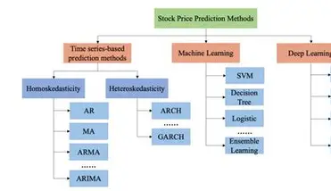
CONCLUSION:
Stock price prediction relies heavily on efficient data structures to handle large volumes of time-series data. Structures like arrays and lists store sequential price data, queues manage sliding windows for moving averages, and hash maps/dictionaries enable quick access to historical records. For advanced models, matrices (via NumPy) and tensors (via deep learning frameworks) are essential for numerical computations.
FUTURE SCOPE:
Stock price prediction is a time-series forecasting problem, and its future scope—especially from a data structures perspective—focuses on how efficiently we can store, process, and retrieve large, complex datasets for better accuracy and speed.
NAME: S. ROHIT
ROLL NO: 25P61A05W6
SUBMITTED TO: Mr .ARUN

